DBMS

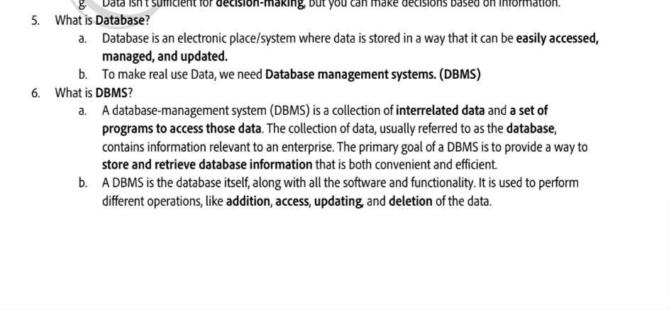

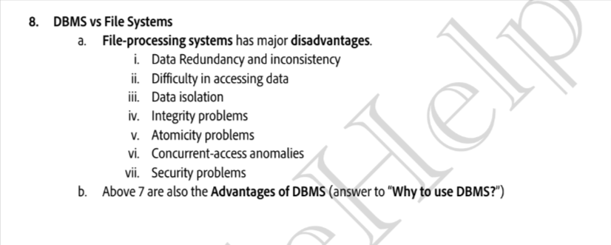

eg of above :

iii)poor isolation eg .txt or .dat

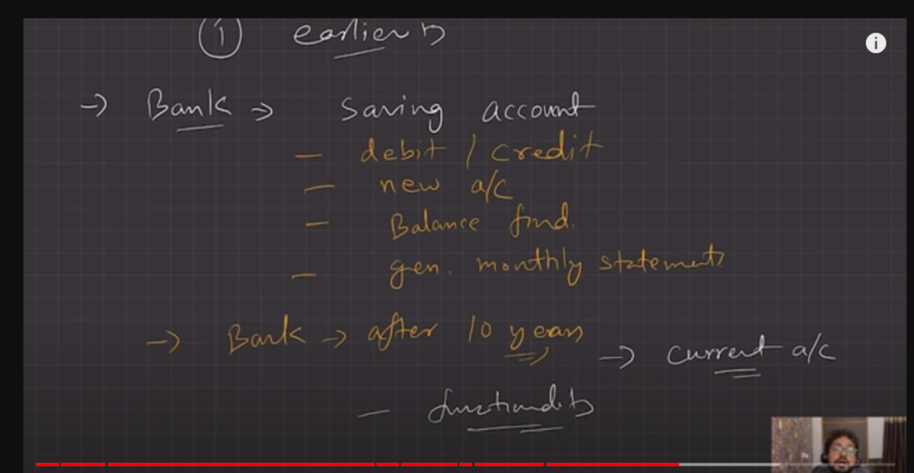

LEC-2

DBMS Architecture

1.Abstaction

Three schema architecture:

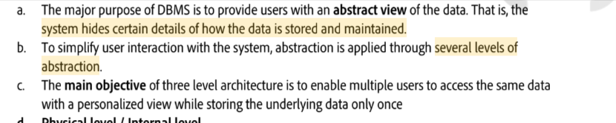

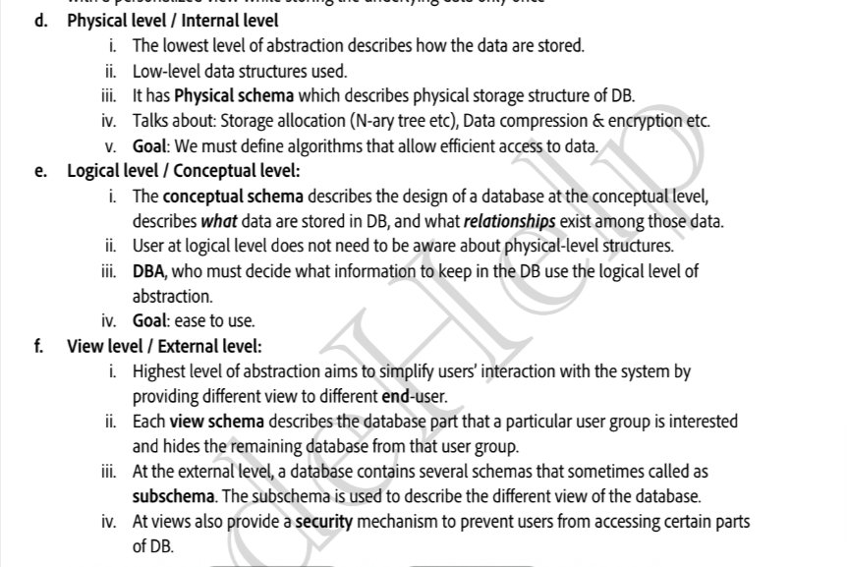

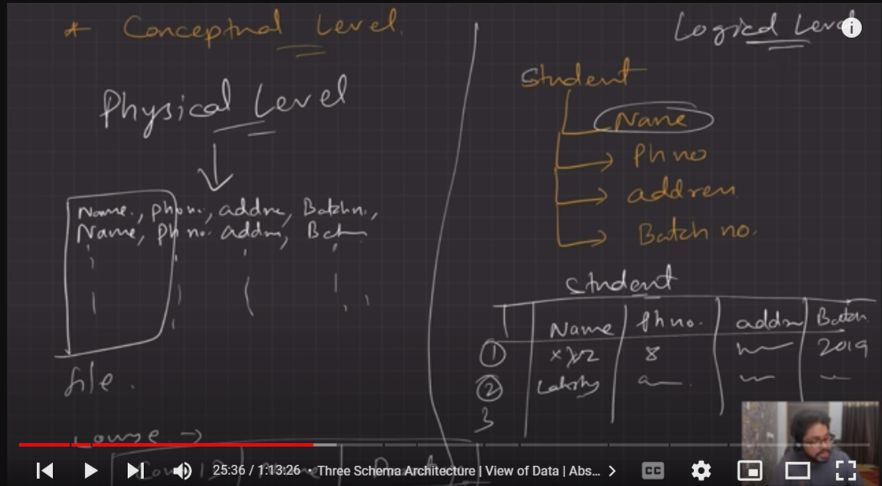

database instance : no of data point present in database at that paticular moment .

databse schemas :

database modals:

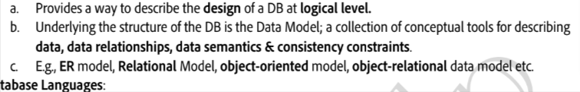

database lanugages:

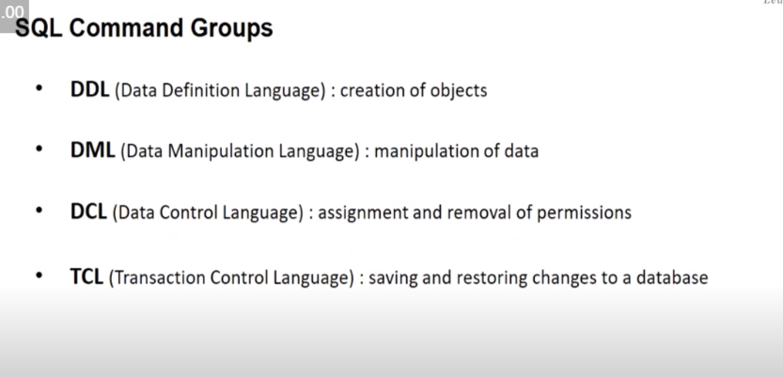

Q.how host language comminicate with the database languages ?

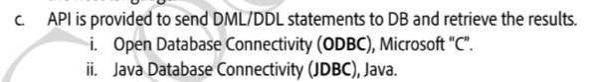

DBA: database administrator

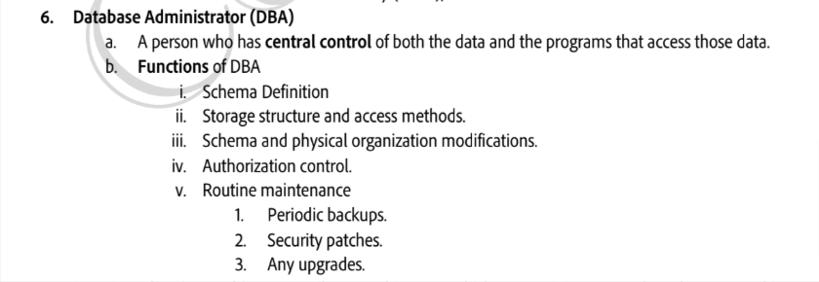

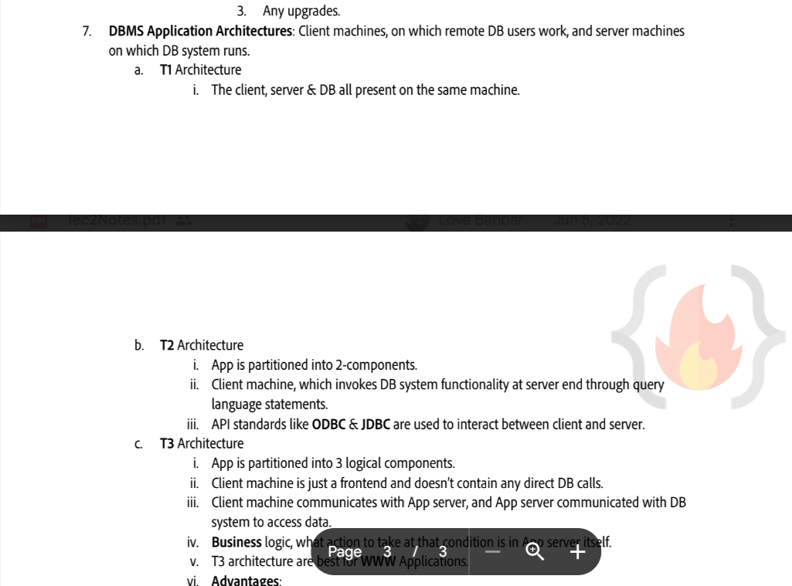

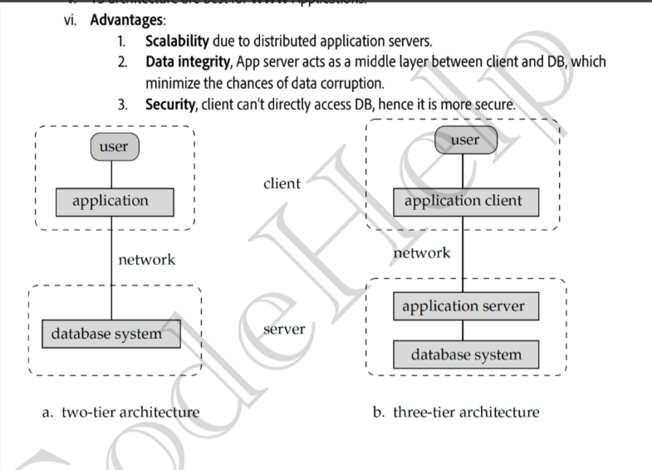

eg of T1 architecture: when application in devlopment stage (localhost , database , client=me)

LEC-3

ER Modal :Entity relationship modal

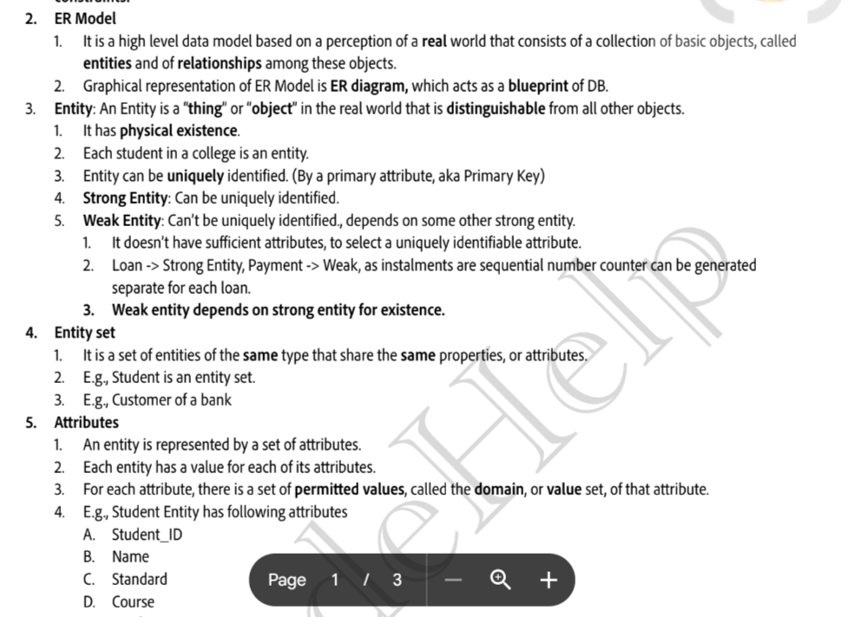

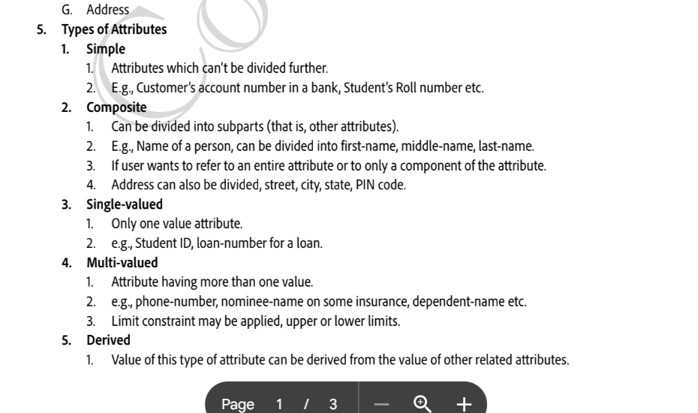

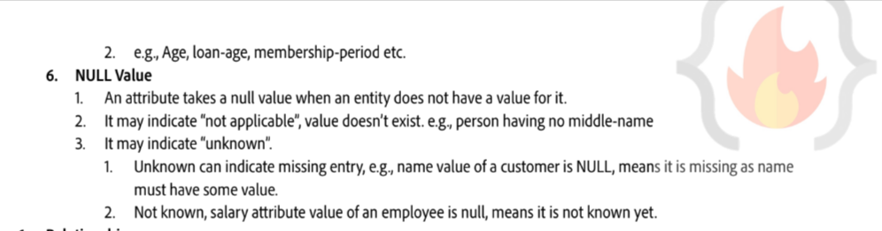

eg of er modal :

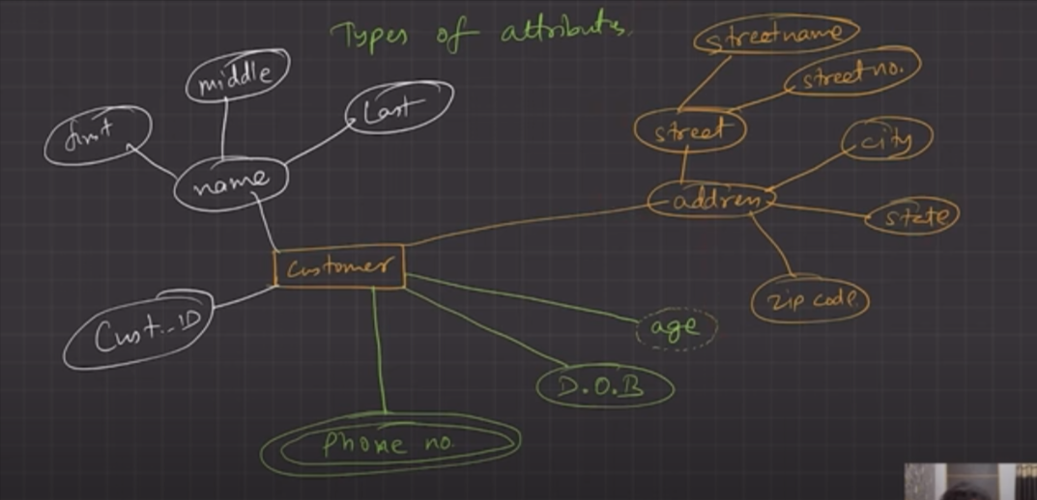

* Normilization

1. functional dependency : it is a relationship between primary key attributes(usually) to that of other attribute of the relation.

eg: id->name (id=deterement and name=dependent)

